Exercício form004.html

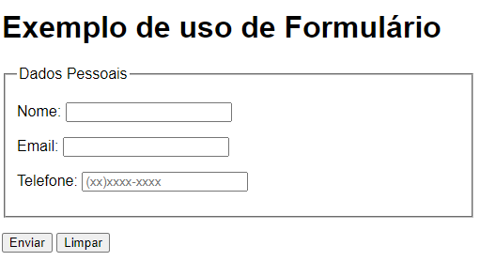

<**body**>

<**h1**>Exemplo de uso de Formulário</**h1**>

<**form** **action**="cadastro.php" **method**="get" **autocomplete**="on">

<**fieldset**>

<legend>**Dados Pessoais**</legend>

<**p**>

<**label** **for**="inome"> Nome: </**label**>

<**input** **type**="text" **name**="nome" **id**="inome" **minlength**="5" **maxlength**="20" **required**>

**</**p>

<**p**>

<**label** **for**="iemail"> **Email:** </**label**>

<**input** **type**="email" **name**="email" **id**="iemail**"** **autocomplete**="email" **required**>

**</p**>

<**p**>

<**label** **for**="itel"> **Telefone:** </**label**>

<**input** **type**="tel" **name**="tel" **id**="itel" **autocomplete**="tel" **required** **placeholder**="(xx)xxxx-xxxx">

<**/p**>

<**/fieldset**>

<**p**>

<**input** **type**="submit" **value**="Enviar">

<**input** **type**="reset" **value**="Limpar">

**</p**>

</**form**>

</**body**>